MongoDB It’s is a document-oriented database that stores data in JSON-like document called BSON.

It’s designed for high performance, scalability, and ease of use.

***Title:*** Creation and updating functions in MongoDB

There are two (2) ways a user can perform a function in MongoDB

* InsertOne({})
* InsertMany({})

So let get started with the “InsertOne” method.

To insert a single document into a collection, use the db.name.insertOne() method.

When you insert a document into the specified collection it checks if the collection does not exist then create it automatically.

So, I insert a single document into a collection and I add a new document with the properties of {studentId: 1, name: "Kehinde", Age: 20, gender: "Male", complexion: "Dark", Address: "Ibadan", course: "ADSE"} into students’ collection. This is the output in command prompt.

Here is the outcome:



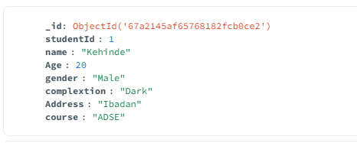

So now let talk about the updateOne() method.

The updateOne() method in MongoDB is used to update a single document in a collection. The updateOne() method can be used with various operators such as $set, $inc and $mul.

Syntax: db.updateOne()

Here is the output:

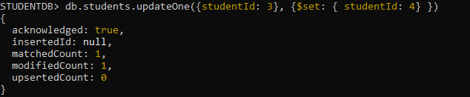

Note: I update the Student with the Id of 3 to be 4.

Before:

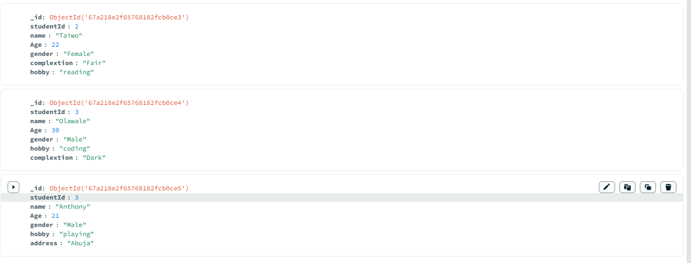

After I update:

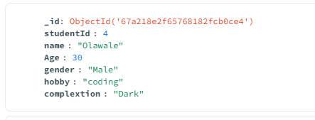

InsertMany()

So let discuss about InsertMany() method.

The insertMany() method in MongoDB is used to insert multiple documents into a collection.

Syntax: db.students.insertMany()

So, I insert a single document into a collection and I add a new

document with the properties of ({[studentId: 2, name: "Taiwo", Age: 22, gender: "Female", complexion: "Fair", hobby: "reading"}, {studentId: 3, name: "Olawale", Age: 30, gender: "Male", hobby: "coding", complexion: "Dark"}, {studentId: 3, name: "Anthony", Age: 21, gender: "Male", hobby: "playing", address: "Abuja"}]) in the command prompt and here is how it looks like

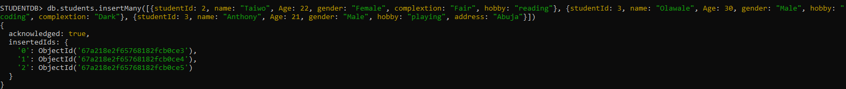

The result I got in the MongoDB compass



Note: I create a student’s database using insertMany()

And that is the output.

UpdateMany()

Ok, now let talk about the updateMany() method.

The updateMany() method in MongoDB is used to update a multiple document in a collection. The updateMany() method can be used with various operators such as $set, $inc and $mul.

Here is the output after I update the document

Command Prompt

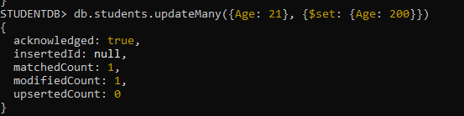

Before I update:

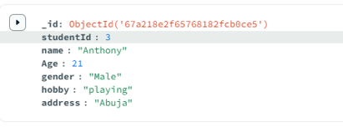

After I update:

